

**Game Analysis:**

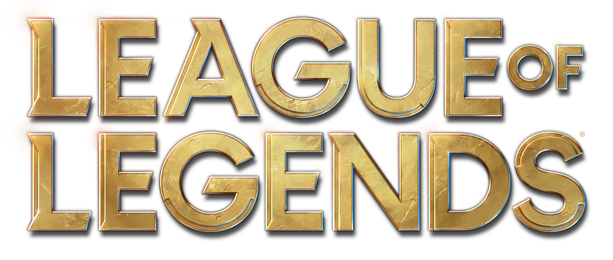

*League of Legends Logo. Riot Games.*

*Author: Calle Wahlstedt Nilsson*

*Summoner name (Europe West): Snabkol*

*Revised: 04/05/2021*

**Table of Contents**

1. Basic Concept..……………………………………....……...………………...3

2. Map…………………………….……………….…………………….……….4

3.Champions………….………….…………………………………...….……....7

3.1. Roles

3.2. Abilities

3.3. Stats

4.Items……………………………………………………...…..………............12

5. Runes & Summoner Spells…………….………………………………...…..14

5.1. Runes

5.2. Summoner Spells

6.Gameplay……….…………………………………………...………………..18 7. Lore……………………………………………....…………………...……...20

8. Summary of the Overall experience……………..…………….....………….26



*League of Legends Logo #2. Riot Games.*

**1. Basic concept**

“League of Legends is a team-based strategy game where two teams of five powerful champions face off to destroy the other's base. Choose from over 140 champions to make epic plays, secure kills, and take down towers as you battle your way to victory.”[1].

“Traverse down one of three different paths in order to attack your enemy at their weakest point. Work with your allies to siege the enemy base and destroy their Nexus! There are three major routes in Summoner's Rift namely: top lane, mid lane, and bottom lane. Each lane has two outer turrets and assigned champions. The top lane consists of fighter melee champions, fighters, assassins, and bruisers, or commonly referred to as AD. The mid lane consists of mages or AP carries. The bottom lane is made up of marksmen or ADC, supports and tanks. The Jungle is a sub-lane where Junglers are assigned to control the buffs and set up ganks. The jungle is made up of monsters with the Rift Scuttler Rift Scuttler being the only non hostile monster and the Baron Baron and Dragon Dragon being the only epic monsters on the map of Summoner's Rift.”[2]

The gameplay of League of Legends can be summed up in different ways. The most thorough of which is probably found on the game’s own fandom Wiki. However in order to grasp the complete design of the game it has to be dissected into its different components & analysed separately.

**2. Map**

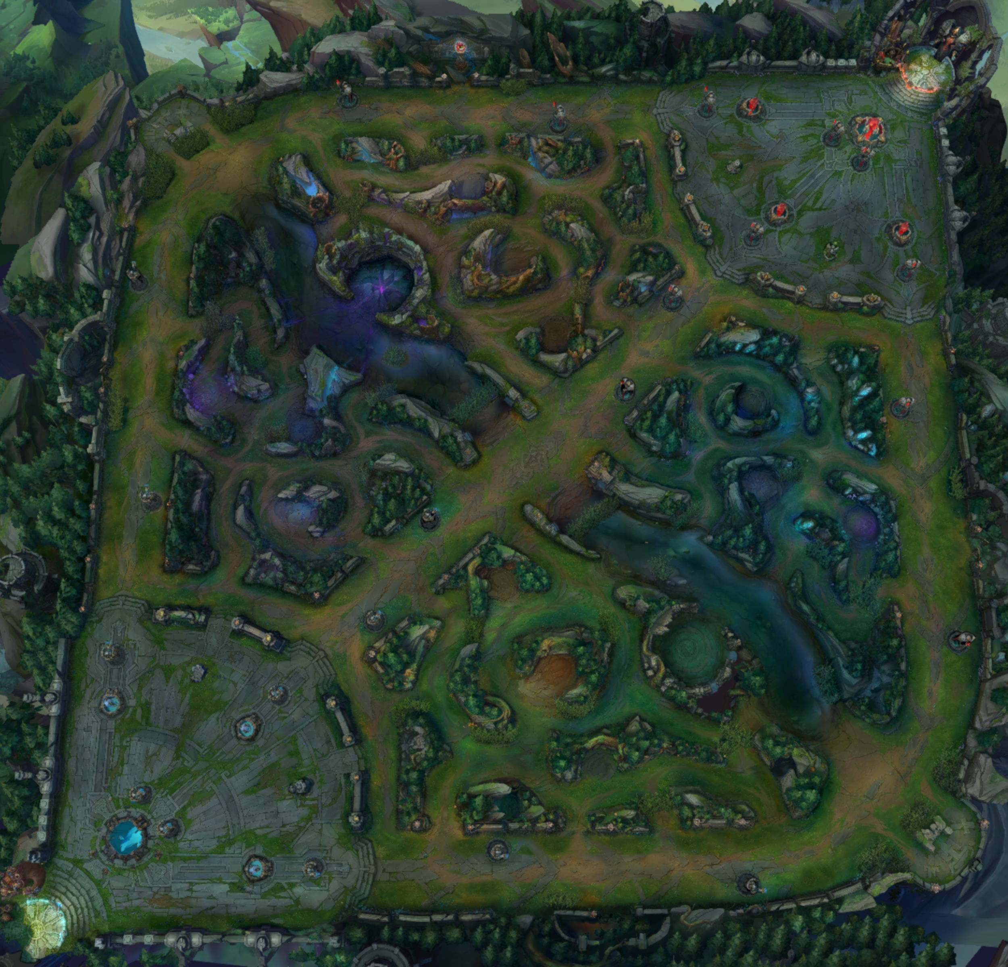

*Overview map of the Summoner’s Rift, the most popular map.*

League of Legends has 3 current maps (has had a total of 12 maps including discontinued & reskin maps):

* The Summoner’s Rift
* The Howling Abyss
* Temple of Lily and Lotus

In this Game Analysis there will be an emphasis on The Summoner’s Rift as it is the most popular way to play LOL and the game design team tends to balance champions & items in accordance to their strength on this map and culture surrounding it.

The Summoner’s Rift is split into 3 lanes and in between them a jungle. In the bottom lane (bot) there tends to go two people, a *Carry* and a *Support*. In the middle lane (mid) is usually a burst mage or assassin. Up in the top lane (top) is usually a tank, fighter or ranged carry. The jungler is the most flexible role where many different archetypes fit in and is utilized often.

In parts of the jungle and on the side of all lanes are bushes, enemies inside the bushes cannot be seen unless the player or a teammate is also inside one of the bushes, the bushes also obscure vision behind them.

In each lane, and in the base of each team are structures. There are three types of structures which are placed symmetrically across the map. Arguably the most important structure is the Nexus. The goal of the game is to defeat the enemy nexus, once you do, your team wins.The most common structure is the turret. Turrets deal damage to any enemy minions, champions or monsters that come too close. There are three turrets in each lane and two turrets protect the Nexus. Each turret cannot be damaged before the previous turret in that lane has been destroyed. The nexus turrets cannot be destroyed before one of the three inhibitors have been destroyed. Speaking of which, there is one inhibitor after the third turret of each lane, just inside the base. After an inhibitor is destroyed the team which destroyed it will have stronger minions spawn in that lane until that inhibitor respawns after 5 minutes.

The jungle is symmetrically split diagonally by the mid lane, except for the Epic objectives which will be covered later in this section. The jungle contains camps of different monsters, some with special rewards.

 Raptors, many small monsters. Area of Effect (AoE) attacks recommended.

Wolves, three monsters with average health and damage.

Krugs, two monsters that split into smaller versions of themselves upon death.

Grump, one large monster with poisoning attacks. Grants health upon death.

Rift Scuttler, a tough pacifist monster which roams the river, gives temporary vision and speed in the river for the team which defeats it.

 Blue Sentinel, a more powerful jungle camp which award a temporary buff to its killer:Crest of Insight “Blue buff”. The Blue buff increases mana regeneration & ability haste. This bonus will last until timed out or upon death where it will transfer to the killer.

Red Brambleback, similar to the Blue Sentinel is a powerful jungle camp which award a temporary buff:Crest of Cinders “Red buff”. The Red buff increases health regeneration out of combat & causes attacks to deal additional damage over time. This bonus will last until timed out or upon death where it will transfer to the killer.

Rift Herald, this EPIC monster spawns in the topside jungle in the *Baron Pit* at 08:00 in-game time then it respawns after 6 minutes. The Rift Herald is powerful and may need several players to defeat. The eye on the back of the Herald’s back will sometimes open, attacking the Herald from behind when this occurs will cause extra damage making the fight significantly easier.Upon death the Rift Herald drops the Eye of the Herald at the edge of the baron pit.The Eye of the Herald can be picked up by any champion who participated in the fight against the Herald. When the eye is picked up it replaces the character’s trinket for a time and empowers the champion’s recall ability. The Eye of the Herald can be consumed, upon use it will spawn a friendly version of the monster which lays siege upon the structures of the opposing team, a devastating charge can easily destroy a turret in a hit or two.

/// The Elemental Drake spawn in the bottom side of the jungle in the *Dragon Pit* at 05:00 in-game time and respawns after 5 minutes. The Elemental dragons are, like the Rift Herald an EPIC monster and may require several players to defeat especially early in the game. The different Drakes have different effects depending on their element. When engaged the drake will attempt to knock all champions out of its pit, take to the air and begin to attack. The Infernal drake’s basic attacks deal AoE damage, the Cloud drake has higher attack and movement speed, the Ocean drake’s attack slow recipients making it harder to escape & finally the Mountain drake deals heavy AoE with slow attacks and have the most resistances of all the drakes. The first three drakes will always be of unique elements, after that all the drakes will be the same as the third spawn. The map undergoes changes after the third drake spawn, what changes depends on the element of the third drake for that game.

For each drake a team defeats it gains a permanent bonus for that game depending on the element of the drake. If one team defeats four drakes they unlock the “Dragon soul” ; the type of soul is depending on the element of the third drake. The Dragon soul is a more powerful permanent buff to the entire team.

The Elder Dragon is spawned after one team has gotten the dragon soul. The Elder dragon is a tougher variant of the elemental drakes and defeating this EPIC monster will grant the buff “Aspect of the Dragon” to all living teammates of the team which slays it.

****Baron Nashor takes over the Rift Herald’s spawn in the Baron Pit at 20:00 in-game time. If the Rift Herald is still alive at 19:45 in-game time he will despawn first. The Baron is considered the toughest EPIC monster in the jungle. He has multiple mechanics to keep track of. If there are champions behind the Baron he will send out a barrage of spikes which deal heavy damage to all units behind him. Champions in front of the Baron will have to deal with his ranged attack which temporarily reduces armour and magic resist. Baron Nashor will also spit out acid in either a line or in three puddles in a cone in front of him. Finally the Baron Nashor can send out one of his tentacles to knock up any champion which stands in it as it erupts from the ground. Slaying the Baron grants a teamwide buff to all alive teammates.

Hand of Baron greatly enhances Attack Damage, Ability Power, The time it takes to use the recall ability and will empower any minions close to the champions with the buff. The Hand of Baron is lost upon death or after 2.5 minutes.

**3. Champions**

**3.1. Roles**

Each Champion can be categorized into 6 different roles.

* Assassins
* Fighters
* Mages
* Marksmen (Also called AD-Carry or ADC)
* Support
* Tanks

Each of these roles have particular strengths and weaknesses and a diverse roster of roles can increase the overall quality of a team composition.



* *Assassins* tend to have low HP values but deal high bursts of damage. Their mobility ensures that they can safely disrupt the enemy backline without getting themselves killed. The assassin is also good at finding players who are badly positioned and eradicate them quickly however, one small misstep and the assassin might be the one to perish.



* *Fighters* are the frontline damage-dealers of a team. They tend to have high upfront damage and their higher health and defensive capabilities ensure their survival when rushing into the fray of battle. Oftentimes the fighters do not have a lot of ranged abilities and are as such susceptible to enemy ranged attacks.



* *Mages* are the glass-cannons of the game. Mages' magic damage-output are usually the highest in the game and can be devastating for the enemy. The zone control they provide with their spells can completely shut out opponents from a fight. Their biggest weakness is usually that with bad positioning they might become sitting ducks waiting to be picked off.



* *Marksmen* (or ADCs) have the highest sustained physical attack damage in the game. They rely heavily on support for survivability but the damage they provide with their basic attacks is well worth it. Skilled marksmen can overcome all 5 of their enemies alone from damage output alone which makes them formidable foes despite their low defense and health.



* *Supports* leave the damage to the carries in favour for a more utility focused playstyle. Whether they are healing, shielding, granting stats or providing great zone control, supports always aid the team greatly. Their biggest weakness tends to be their lack of damage and survivability for themselves which makes them rather useless once their carries are out of the picture.



* *Tanks* are the burly protectors of the meek. Their defense and health provides great protection for their supports and damage dealing carries. The tanks bring zone control and moderate sustained damage to disrupt the enemies positioning and make them easier to be picked off. The biggest weakness of a tank is that they themselves do not have a lot of damage output and may simply be outburst by enemy carries. They also tend to lack mobility so if they overstay their welcome the enemy team might bring them down.

Most, if not all, champions are designed with two roles in mind. The champion Darius for example is a mix between Fighter and Tank, meaning he has both a lot of damage and sustainability but very little in terms of mobility whilst Aurelion Sol, another champion of the game is a mix between tank and mage meaning, he has a lot of burst damage and decent survivability but not high sustained damage. There are exceptions to the different classes where some tanks have a lot of mobility as an example. The exceptions usually have other weaknesses to make sure the champion feels fair to play as, and against.

**3.2. Abilities**

Generally, a Champion has 4 different activated abilities + a passive ability. For each level the player is given 1 ability point to assign to their primary, secondary or tertiary ability which unlocks or further increases the potency of the ability. The fourth ability is referred to as a champion’s ‘Ultimate ability’ and can only have points assigned to it after level 6, 11, 16 & 18. The passive ability cannot have ability points assigned to it but may improve as the champion levels up also.

Every champion has different stats, most of which are covered later in this section. The most important ones for Champions are *Attack Damage* (AD), *Ability Power* (AP), *Health* (HP) and *Mana*. The abilities of a champion can *scale* with any of these stats meaning that their potency is increased based on a flat percentage of the champion’s stat-scores.

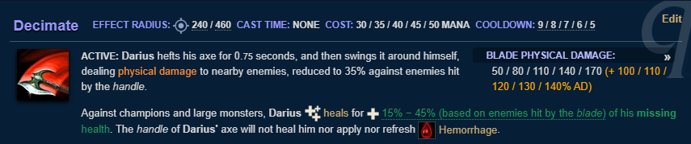

*Example 1. Darius’ primary ability: “Decimate”[3]*

In this example of Darius’ primary ability all the different variables are shown:

* Effect Radius: How far the ability reaches.
* Cast Time: Whether there is a charge-up time before the ability can be cast and how long it takes.
* Cost: Resource Cost, in Darius’ case it is mana. This cost tends to increase as the level of the ability is increased.
* Cooldown: How long you have to wait after casting the ability before you can cast it again.

On the right-hand side under “Blade Physical Damage”, the damage numbers (per ability level) are shown with the Attack Damage Scaling (AD-Scaling) in orange brackets. A 1st level Decimate has 100% AD-scaling meaning that all of Darius’ AD will become extra damage for this ability. The rest of the information on the ability is not currently relevant for this analysis.

As the primary ability button (Default:Q) is pressed Darius revs up his axe and strikes every unit in a circle around him. The ones hit by the blade of his axe take additional damage and are affected by Darius’ passive ability “Hemorrhage”, a damage over time (DoT) effect.

**3.3. Stats**

Champions have 25 different statistics which can be sorted into 3 different categories:

1. Offensive

The offensive category of champion statistics are rather self explanatory, these stats increase the offensive capabilities of the champions, certain statistics more effective for certain champions as per their design. The offensive statistics are as follows:

* Ability power (AP)
  + Provides scaling for magic abilities. All champions have 0 base AP and additional AP can only be granted via items, runes or other bonuses.
* Armor penetration (Lethality)
  + Armor penetration causes a champion to ignore a percentage of the opponents armour. *Example: 10% armor pen. causes a target to take physical damage as if it had 10% less armor.*
* Attack damage (AD)
  + Provides scaling for physical abilities. AD determines the amount of damage dealt by basic attacks. Champions have different base AD, which can be increased via level-up, items, runes and other bonuses.
* Attack speed
  + Attack speed determines the frequency between a champion’s basic attacks. Champions have differing base Attack Speeds which can be increased via level-up, items, runes and other bonuses. Attack speed is capped at 2.5, at 2.5 attack speed a champion would attack once every 0.4 sec.
* Critical strike chance (Crit%)
  + Crit% increases the chance that a basic attack or ability will critically strike (dealing 175% of its normal damage). All champions start with 0 Crit% but this can be increased with items, runes and other bonuses. Crit% is capped at 100.
* Critical strike damage (CritDMG)
  + CritDMG is the bonus damage a critical strike does. The base CritDMG is always 175% but it is affected by certain items and champion abilities.
* Life steal (LS)
  + LS grants healing equal to a percentage of the damage dealt by basic attacks and certain abilities. LS is not affected by Heal & Shield Power. Champions start with 0 LS but this can be increased with items, runes and other bonuses.
* Magic penetration
  + Magic penetration causes a champion to ignore a percentage of the opponents Magic Resist.
* Omnivamp
  + Omnivamp grants healing equal to a percentage of the physical, magic and true damage dealt. Omnivamp is affected by Heal & Shield Power. All champions start with 0 omnivamp but can increase it with items, runes and other bonuses.
* Physical vamp
  + Physical vamp grants healing equal to a percentage of the physical damage dealt. Physical vamp is affected by Heal & Shield Power. All champions start with 0 Physical vamp but can increase it with items, runes and other bonuses.

1. Defensive

The defensive statistics are also rather obvious by their name. These statistics make a champion hardier, tougher or more resistant to the AoE or CC effects of opponents. All of these statistics vary from champion to champion and can be increased (and/or decreased) by items, runes and other effects.

* Armor
  + Mitigates damage taken from basic attacks and abilities which deal physical damage. The base armour is different for each champion. Armour increases with level, items, runes and other bonuses.
* Heal & shield power (HSP)
  + Increases the effectiveness of heals and shields a champion applies to themselves and allies. Champions start with 0 HSP but can increase this with items, runes and other bonuses.
* Health (HP)
  + Increases the amount of Health Points your champion has. When a champion’s HP is reduced to 0 they die. Health differs between the champions and is increased with levels, items, runes and other bonuses.
* Health regeneration
  + The rate in which you regenerate lost HP over time. Health Regeneration is increased slightly with each level and can be increased with items, runes and other bonuses.
* Magic resistance (MR)
  + Mitigates damage taken from abilities which deal magical damage. Magic resistance, similar to armour is different for each champion and increases with levels, items, runes and other bonuses.
* Tenacity
  + Reduces the duration of different crowd control effects (ex. Slows, stuns, snares, etc.), however, the duration of the crowd control cannot drop below 0.5s. Champions do not start with any tenacity, nor do they gain tenacity via levels. Tenacity can be increased with items, runes and other bonuses.

1. Utility

Utility stats are the remaining stats on the list. They do not directly impact neither offense nor defense. Though these statistics may help with quicker recoveries between skirmishes or with keeping up with the enemy economically.

* Ability haste (CDR)
  + CDR reduces the time after an ability is used by a champion before it can be used again, also known as the Cooldown (CD). All champions start with 0 CDR, but is can be increased by items, runes and other bonuses.
* Mana/Energy
  + Mana and energy are two resources which are used by many different champions to cast their abilities. Mana tends to more plentiful with the drawback of slower regeneration whilst energy has more regeneration but is less abundant. The amount of mana/energy varies between the champions, however, it can be increased with levels, items, runes and other bonuses.
* Mana/Energy regeneration
  + The rate of which mana and/or energy regenerates over time. This rate can be increased by levels, items, runes and other bonuses.
* Gold generation
  + The rate of which gold is passively generated. Gold generation on the Summoner’s Rift is 20.4g/10s. This can be increased with certain items. Additional gold can be generated by dealing the killing blow on a minion or monster, a takedown against an enemy champion, destroying a turret or its plating, destroying an enemy ward or taking a major objective (Dragon and/or Baron).
* Movement speed (MS)
  + The speed of which a unit traverses the map. Champions have different base movement speed. This MS can only be increased with items, runes and other bonuses.
* Range
  + Range is the distance in which a champion’s basic attacks and abilities can reach. Champions may have different ranges on their basic attacks and abilities. Some items and other bonuses increase the range of basic attacks.[4]

**4. Items**

Items are the main source of customization within a game of LOL. Items can be categorized into 8 different categories.

* Starter items
* Basic items
* Epic items
* Legendary items
* Mythic items
* Boots
* Consumables
* Trinkets

**Starter items**

The starter items are rather simplistic with a cheap cost and statistical gain. There are starter items for every archetype of champion and special items for the support and jungler roles. The items for supports are upgraded as the game goes on.

**Basic items**

Basic items are also relatively cheap with low statistical gain. They differ from starter items however, as basics items are components for Epic items. The basic items seldom have special effects outside of stats.

**Epic items**

The next tier of components are referred to as Epic items. They require certain basic items to be bought before buying. The epic items often have more stats, or even a unique activated or passive ability tied to them. They are in turn components for Legendary & Mythics items.

**Legendary items**

Legendary items are the most impactful items outside of Mythic items. The Legendary items always have unique activated and/or passive abilities which empower your character greatly. These are the items necessary to keep up with your opponents and overpower them.

**Mythic items**

The most impactful items are the mythic items. They are similar in cost to Legendary items but their unique abilities will change the way you play the game. And as such the Mythic items are limited to one per character per game.

**Boots**

Whilst Boots may seem silly they are among the most effective items for catching up to opponents or running away from them. Normal boots will build into many different boots with certain characteristics which fit different champions, situations & playstyles.

**Consumables**

Consumables are as the name suggests consumed upon use. Most consumables are potions granting either health regeneration or other bonuses. Another Consumable of note is that of the Control Ward.

**Trinkets**

A player can have 1 out of 3 trinkets. All are related to vision of the map. Trinkets are also free and can be swapped at any time the player is at the store.

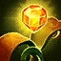Stealth Ward, The Stealth Ward allows a player to place an invisible ward which grants vision for the team for a set duration. A variation of the stealth ward is the consumable item  Control Ward, which places a *visible* ward which also reveals invisible units in its vicinity as well as granting vision to the team.

Farsight Alteration, The Farsight Alteration causes temporary vision on a larger range. It also places a visible ward which grants less vision than regular wards but does not expire.

Oracle Lens, The Oracle Lens reveals invisible units, wards & also disables traps in a small area around the player. Great for removing enemy wards and traps.

**5. Runes & Summoner Spells**

**5.1. Runes**

Runes are the primary form of customization before a game has begun. When picking runes the player is given the choice between 5 different paths. 1 primary path will give a *Keystone* which are powerful and impactful abilities which affect playstyle, the primary path. A secondary path can be chosen together with the primary and grants additional stats, however in the secondary path only 2 slots may be used.

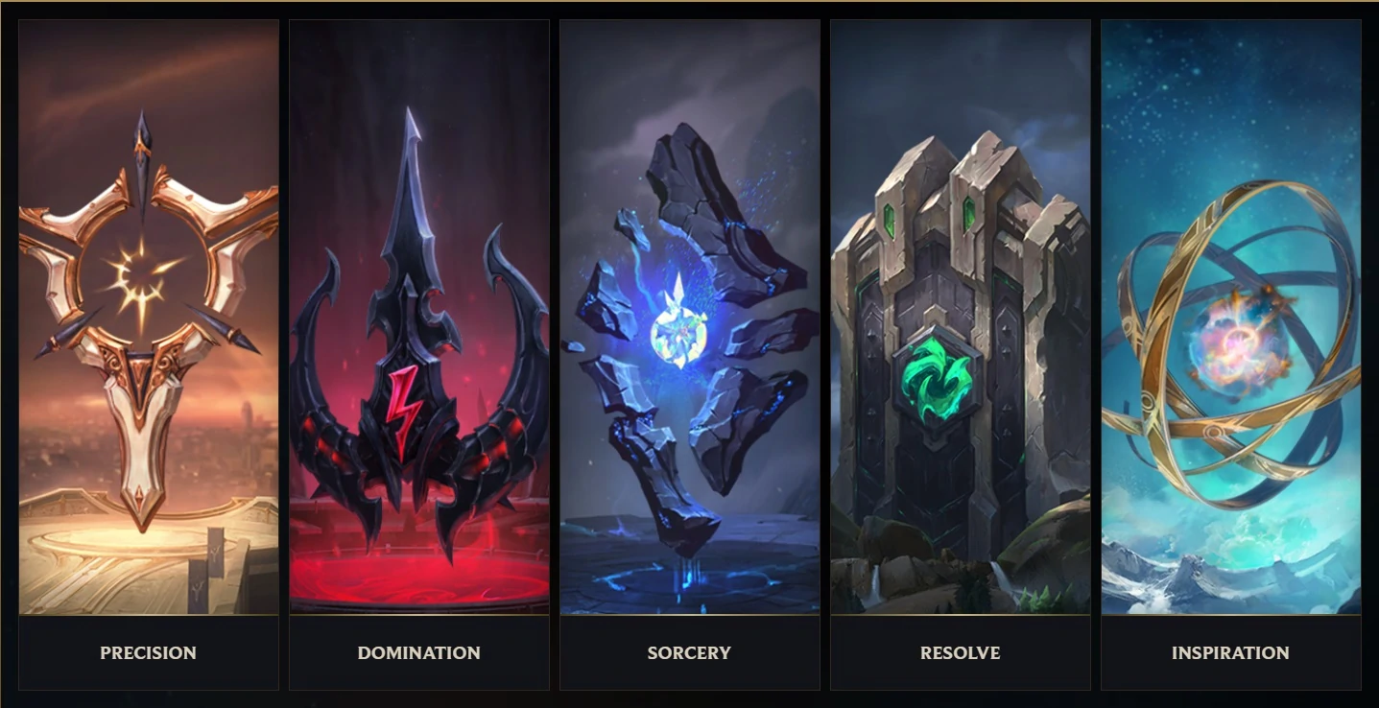

*The Different rune Paths. Riot Games.*

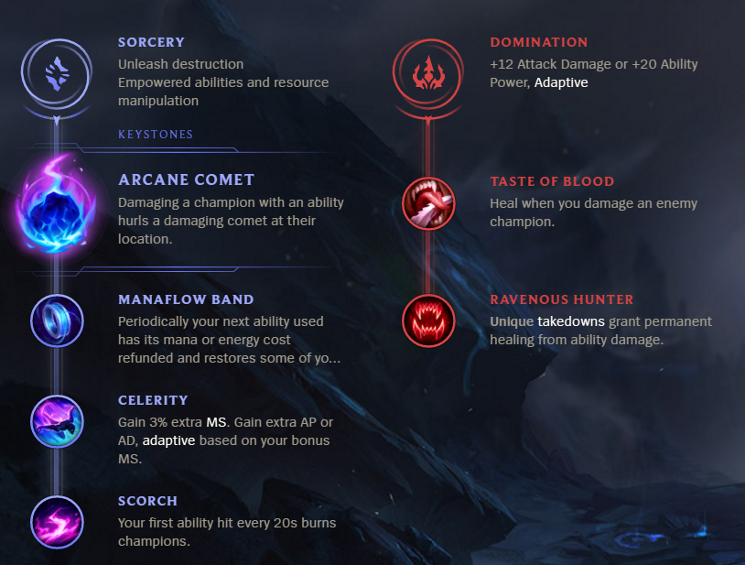

*An example of two rune paths.[5]*

In this example the primary path *Sorcery* and the secondary path *Domination* have been chosen. The *Keystone* is “Arcane Comet” and the stat bonus for choosing Domination as secondary is shown. The different paths are as follows:

* Precision
  + Improved attacks
  + Sustained Damage

Precision is all about making sure that once the enemies are in your grasp, they will not escape as your sustained damage will plow their HP down or that your movement speed will allow you to pursue your enemies until they falter.

* Domination
  + Burst Damage
  + Target Access

The domination runes will allow champions to have an easier time getting into the fray, or allow for harder hitting bursts of damage once they’ve engaged the enemy.

* Sorcery
  + Empowered Abilities
  + Resource Manipulation

Sorcery allows for management of your champion’s resource all while making sure to squeeze some extra value out of them. Whether it is providing extra shields or damage to your opponents sorcery will provide.

* Resolve
  + Durability
  + Crowd Control

Players who use the resolve runes will be sure to have more defensive capabilities whilst also rewarding good zone control.

* Inspiration
  + Creative Tools
  + Rule Bending

Inspiration allows for *interesting* mechanics and ideas to be implemented into the game whether it is randomized bonuses or cheating on gold, inspiration has something for you.

* Shards
  + There are 3 slots of shard runes which are unrelated to the skill trees and can be exchanged independently of each other.

|  | **Option 1** | **Option 2** | **Option 3** |
| --- | --- | --- | --- |
| **Slot 1**  Offense | 5.4 AD or 9AP  (Adaptive) | 10% bonus Attack Speed | 8 Ability Haste |
| **Slot 2**  Flex | 5.4 AD or 9AP  (Adaptive) | 6 bonus Armor | 8 bonus Magic Resistance |
| **Slot 3**  Defense | 15-90 (based on Lvl.) bonus Health | 6 Bonus Armor | 8 bonus Magic Resistance |

**5.2. Summoner Spells**

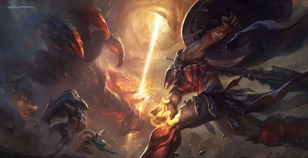

*The Champion Pantheon casting the summoner spell ‘Smite’ on a Brambleback . Riot Games.*

Summoner spells are the secondary form of customization before the beginning of a game. They are additional spells which cost nothing but tend to have a long cooldown, they also do not scale with anything but level. A well timed summoner spell can be the difference between the win and loss of a fight, or even an entire game. This leads the player to use them sparingly only when they can capitalize on the benefit it brings. There are 11 Summoner spells:

Heal: Heals, and gives temporary movement speed to the user and an additional friendly Champion in the vicinity. Great for saving yourself and an ally from certain demise.

Ghost: Upon use your champion gains increased movement speed and ignores unit collision. Defeating an enemy champion grants additional time until the movement speed runs out. Great for catching up with or running away from enemies.

Barrier: Gives the user a large temporary shield for a short period of time. Great to withstand quick burst damage.

Exhaust: Reduces both movement speed and damage dealt of an enemy champion for a short period of time.

/Mark/Dash: Throw a snowball a long distance. Upon hitting an enemy champion deal a small amount of true damage and marks the target. Whilst a champion is marked by a snowball you can activate it again in order to dash to the marked champion. Great for engaging the enemy. This summoner spell is exclusive for the *Howling Abyss* map.

Clarity: Restore mana to the user upon use, and nearby allies get half as much mana recovered.

Flash: Instantaneously teleport the user’s champion in the direction of their cursor. Great for collapsing upon the enemy or escaping over a wall.

Teleport: Teleport the user’s champion to a friendly turret, minion or ward. The user gets temporary movement speed upon arrival. Great for pressuring other lanes quickly or returning to lane after perishing.

Smite: Deal a high amount of damage to neutral jungle camps, minions or pets. Using smites against large monsters also heals the user. This summoner spell can have up to 2 charges and can be upgraded with items.

Cleanse: Removes all crowd controlling effects from the user and grants temporary tenacity. The goto summoner spell against crowd-control heavy team compositions.

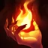Ignite: Sets an enemy champion aflame revealing them and dealing Damage over Time (DoT) and applies Reduces healing taken on the target for the duration.

**6. Gameplay**

There are 4 distinct phases of gameplay in League of Legends:

1. Champion Select/Draft

The champion draft is the first part of the game. Depending on the gamemode which is played different rules may apply. For the most common gamemode which is “Draft” the following rules apply:

* A team at random is assigned as the first pick and the players are randomly assigned a pick order.
* Each player on both teams may ban a champion. A banned champion cannot be picked by either team, this is great in order to avoid a character which may be frustrating to play against or is a favourable pick due to team compositions. However, the bans can cause frustration as a player may want to pick that champion.
* The player highest in the pick order of the first team gets to pick 1 champion. Afterwards, the second team gets to pick two champions, the first team gets to pick 2 additional champions and so on, until all players have picked a champion.
* After picking a champion, a player may customize the cosmetics they bring onto the battlefield, these cosmetics do not bring any competitive advantage. The players may also customize runes and summoner spells (Covered under *5.1* and *5.2*) these may have competitive advantages and disadvantages.

1. Early Game/Laning Phase (00.00-20.00 min)

| Jungle | Lane |
| --- | --- |
| Start with killing a jungle camp (usually blue/red buff depending on what side the player is on and what champion they are playing). Continue to kill jungle camps and look for opportunities to disrupt enemy laners and engage a 2v1 skirmish. Some junglers prefer to intercept the opposing jungler by taking their camps, as they do not mind early one on one skirmishes.  The jungler has to find a good balance between these disruptions in the lane and farming monsters in the jungle as to not fall too far behind but still giving aid to the laners which may struggle or just want an additional early lead.  The jungler is also responsible for initiating attempts to defeat the dragon early as the summoner spell ‘smite’ can be integral to the success of the endeavor. | The lane closest to the jungler’s first preferred camp tends to ease the process a bit by dealing some damage to the camp for them (leashing). The players return to their designated lane and farm minions for gold. Looking for opportunities to trade blows and start skirmishes to disrupt or kill enemy champions.  The laners will attempt to apply pressure by killing the enemy minions quickly so that the opponents have to stabilize the minion waves. This gives the laners time to help take objectives, recall to base in order to buy items and further increase their power for the rest of the game. |

1. Midgame (20.00-35.00 min)

| Jungle | Lane |
| --- | --- |
| The jungler focuses more and more on the epic objectives (Dragon, Rift Herald & Baron Nashor). Contest these objectives and gain advantages for disrupting the enemy or defeating the objectives with your team, for your team. All while defeating camps and aiding in lane when appropriate.  A jungler that is ahead in gold and levels can focus harder on objectives and helping allies, whilst a jungler who lags behind might have to focus instead on farming their jungle for gold and experience. | Lanes are more fluid at this stage of the game with the swapping of lanes with allies and roaming in order to match the opposing team’s pressure. A larger focus on small groups and skirmishes between them. The team with a more successful laning phase tends to act as aggressors, applying pressure to objectives opening up opportunities for the opposing team to disrupt them.  A team that is behind has to focus on staying alive and not furthering the lead of their opponents whilst also farm in lane and try to contest objectives.  During this time certain team compositions might have a chance to apply enough pressure upon their enemies so that they can destroy their base and eventually win the game. |

1. Late Game (35.00-60.00+ min)

| All |
| --- |
| This stage of the game harbours the greatest power within champions and certain team compositions shine at this stage whilst others might suffer. The late game tends to end up in one of three ways. If the teams are equal in terms of power there may be competition surrounding Baron Nashor and the Elder Dragon, two very strong objectives. A single fight at this stage of the game can easily lead to a loss due to the sheer power of champions. If the teams’ power distribution is unevenly distributed then the game will either be a one-sided siege with a valiant defense effort or a clutch turn-around in the game’s dynamic should the defense succeed.  The game tends to end either at the verge of the late game or drag out further depending on how well the teams navigate the match. As is tradition the winning team tends to exclaim the sacred words in the chat for the losing team to look at with defeat in their eyes: **GG WP** (“Good Game, Well Played”). |

**7. Lore**

The Lore of League of Legends takes place in the world of Runeterra. Each individual champion has lore connected to the world. Not all champions act simultaneously but the consequences of one champion’s story can oftentimes be seen in the presentation of Runeterra. There are 3 large continents on Runeterra, Valoran is the northernmost continent to the south of Valoran lies the Shuriman continent and to the east lies Ionia. There are large regions of Runeterra with distinct themes and aesthetics. The lore can be accessed online for free on Riot’s official site in the form of comics, short stories and many other forms of media. The lore has become so popular an animated Netflix series has been announced for 2021.[6]

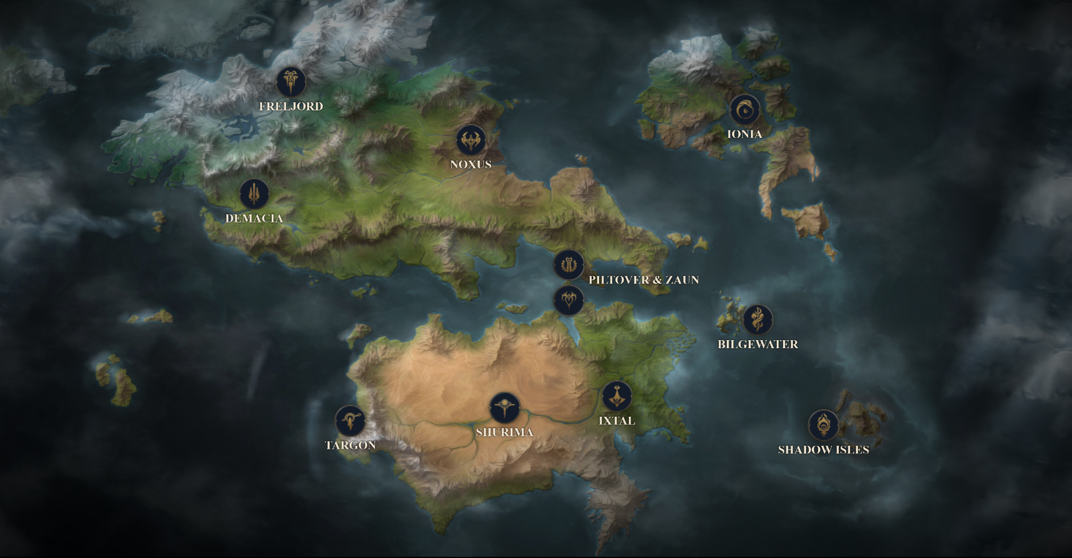

*Official map of Runeterra. Riot Games.[7]*



**Bandle City**

Bandle City is the magical realm of the *Yordles*. A world hidden from sight by curious unseen pathways. The lands of Bandle are magical, colorful and spiritual. Few non-Yordles ever venture into Bandle and even fewer agree on what they saw there. Only one thing is certain, the land is timeless and so are its inhabitants. Bandle city is as of yet one of the more mysterious places on Runeterra, as it is located in the *spirit realm* and is not often covered in the lore as such.

* Related Champions: Teemo, The Swift Scout, Tristana, The Yordle Gunner & Veigar, The Tiny Master of Evil.



**Bilgewater**

Bilgewater is an island off the eastern coast of Valoran. Bilgewater is a harbor city filled with the outlaws and scum of Runeterra. Murders for hire, criminals and thieves lurk across the briney streets of the surrounding islands. The syndicates with the power survive, thrive & rule. Bilgewater is currently under the govern of *Sarah Fortune’s* gang the Syrens after a successful coup against the previous ruler The Reaver king*, Gangplank*.

* Related Champions:Gangplank, The Saltwater Scourge, Fizz, The Tidal Trickster & Twisted Fate, The Card Master.



**Demacia**

Demacia is a lawful militaristic kingdom which values justice, honor & duty. Their cultural heritage is a point of pride for the demacians but despite this the kingdom has become more isolated in recent centuries. The Great City of Demacia was founded as a refuge after the terrible *Rune Wars* which scarred Runeterra. The *Petricite* forests which surround the city had a dampening effect on the magic however magic still seeps into the region at times which is a cause of conflict for the people who deem that the young *King Jarvan IV* cannot protect them.

* Related Champions:Jarvan IV, The Exemplar of Demacia, Galio, The Colossus & Lucian, The Purifier.



**Freljord**

The northern wastes of Freljord are unforgiving and independent. Its inhabitants are natural warriors with a culture akin to real-world vikings. There are many tribes in Freljord but the largest ones are the *Avarosan* (Led by *Ashe*) the *Frostguard* (led by *Lissandra*) & *Winter’s Claw* (Led by *Sejuani*) these three clans are in eternal conflict over the frozen tundra which they call their home. The Freljord is also home to some of the most visible gods in Valoran, namely *Ornn*, *Volibear* & *Anivia*.

* Related Champions: Ashe, The Frost Archer, Ornn, The Fire Below the Mountain & Trundle, The Troll King.



**Ionia**

The archipelago of Ionia (The First Lands) is a small continent east of Valoran which is said to hold great beauty & natural magic. Here the spirits are said to live in harmony, however the different cults & orders do not. The different ideals and paths often cause conflict, despite this Ionia has been largely neutral in the worldly conflicts, that is until Noxus invaded. Ionia is also home to the spirit-human hybrids known as *Vastaya*, and tales of the titans which roamed the land still appear in oral culture and tradition.

* Related Champions: Shen, Eye of Twilight, Karma, The Enlightened One & Ahri, The Nine-Tailed Fox.



**Ixtal**

The Ixtal jungles are home to an ancient civilization and one of the first independent nations to join the Shuriman empire. Ixtal is said to have been influencing the formation of Buhru (Bilgewater), Helia (The Shadow Isles) & even Targon. The Ixtali are also rumored to have played a role in the creation of the first *Ascended*. The nation survived many assaults by both *Void* & *Darkin* by shielding themselves in a perilous jungle.

* Related Champions:Qiyana, Empress of the Elements, Rengar, The Pridestalker & Zyra, Rise of the Thorns.



**Noxus**

The brutal Empire of Noxus is an expansionist and threatening state to its enemies but inclusive and welcoming to its citizens and allies. The history of Noxus goes far back as a fierce warrior culture, however nowadays their struggle for survival has made the Noxians proud people who value strength over all. Anyone can rise to power in Noxus if they show the required determination and strength to do so.

* Related Champions: Swain, The Noxian Grand General, Kled, The Cantankerous Cavalier & Mordekaiser, The Iron Revenant.



**Piltover**

The City of Progress, Piltover, is a highly cultural and influential place where art, craftsmanship & innovation thrive. It sits atop the district of Zaun, overlooking the ocean. Piltover is a large bazaar for trading which has granted the region its means for furthering research for Valoran’s benefit. The most significant breakthrough is the utilization of *Hextech crystals* as an energy source for creation & destruction alike.

* Related Champions:Heimerdinger, The Revered Inventor, Ezreal, The Prodigal Explorer & Vi, The Piltover Enforcer.



**Shadow Isles (Formerly the blessed isles)**

The Shadow Isles were once a hidden civilization praising knowledge, philosophy and served as protectors of magical artifacts. After a terrible cataclysm ruined the realm only dark & terrifying magic remains and a black mist holds a tight grasp of the island. Each year it seeks to extend its reign to raise those of fall and gather the souls of all inhabitants of Runeterra in an event known as *The Harrowing*.

* Related Champions:Viego, The Ruined King, Maokai, The Twisted Treant & Thresh, The Chain Warden.



**Shurima**

The once mighty empire of Shurima stood upon the sands in growth and prosperity. Governed by emperors & served by slaves. The last emperor *Azir* was betrayed by his close friend and slave *Xerath* which led to the empire’s ruin. *The Ascended* are god-like beings born from the *Sun Disc* who act as guardians throughout the fallen empire. Nowadays, the mostly nomadic people of Shurima roam the desert longing for their emperor’s return.

* Related Champions:Azir, The Emperor of Sands, Nasus, The Curator of the Sands & Sivir, The Battle Mistress.



**Targon**

Mount Targon is a mountain to the west of Shurima where the most determined pilgrims, dreamers & adventurers find the celestial magic of Runeterra speak to them. *The Solari* and *Lunari* are the main orders but many powerful beings known as the *Aspects* are drawn to this place to serve Runeterra and its inhabitants and protect them from the void.

* Related Champions: Aurelion Sol, The Star Forger, Leona, The Radiant Dawn, & ****Taric, The Shield of Valoran.



**The Void**

The Void is the manifestation of the “unknowable nothingness that lies beyond”. It hungers for all and will stop at nothing to annihilate life as we know it in wait for their mysterious masters: *The Watchers*. Many of the champions which originate from here take the shape of what the Watchers imagine the world to look like, and have great adaptability or destructive capabilities.

* Related Champions: Vel’koz, Eye of the Void, Kassadin, The Void Walker & Cho’gath, The Terror of the Void.



**Zaun**

The city of Iron and Glass, Zaun, is the Piltover undercity. The noxious gases and polluted streets block out the light for its inhabitants and the industrial architecture works as a contrast to Zaun’s previously symbiotic relationship with Piltover, now crumbled into dust. The black markets and dubious research only proves the volatile lifestyle which is festering in the cityscape. Even in the most toxic environments the Zaunites find their ways of life, with or without morals.

* Related Champions:Ekko, The Boy who Shattered Time, Janna, Storm’s Fury & Singed, Mad Chemist.

There are many more stories and champions related to these areas as well as more small areas which aren’t covered in this analysis. The lore is completely optional and the game can be enjoyed just as much without it. However certain details in the lore can be found in banter between champions, champion abilities or even emotes which does strengthen the ludonarrative of the game and could bring extra enjoyment to some players.

**8. Summary of the Overall Experience**

The players face the challenges of the jungle, minions, the enemy structures and of course, the enemy champions. The players can utilize their individual champions’ abilities, magical items & ability to work as a team in order to overcome these threats. The team which can outwit, outman or just overpower their enemies the best tend to end up as the winners. The developers at Riot have chosen this approach as it is rather simple and somewhat self-explanatory. Everything is against you except your team and your structures which are clearly colour coded.

The players have many different effects on other players in the game. Opponents will try to harass the player and their allies in order to reduce their gold income, objective kills and general control over the map all the while the player and their team will do the same towards the opponents. The most clear way in which the players affect each other is through skirmishes where one team tends to get a small lead in the form of a kill or secured objective. Players will also affect each other just by control of the map in the form of crowd control and the very presence certain champions can possess which makes them threatening to approach. The players can also chat with each other which, unfortunately, has had an historical effect of toxicity within the game. Name-calling, bullying, verbal harassment, etc. is not too uncommon from the losing team. The chat can also be used for general communication and even praise which makes it a valuable necessity within the game.

The game varies in perceived fairness depending on the skill level of the players. The lower skilled-players may have difficulties with game mechanics and as such games at that level can be very much affected by the snowball-effect, one team gets a minor lead which escalates into a dominance which cannot be broken and as such they win the game. In higher levels of skill mechanics and counterplay are more prominent which lead to a less oppressive snowball-effect and a more balanced gameplay, perceptively.

Some minor issues of fairness occur when discussing balancing, metas & drafting. Sometimes a champion is objectively strong number-wise and that can skew teams to either forcing someone to pick that champion or pick a champion which can be effective against them. It tends to be healthy for diversity as balance-fixes are frequent but sometimes the power of an individual champion can be detrimental for fairness and enjoyment. Thankfully, Riot Games are quick to hear the complaints of their players and solve these problems as they appear.

League of Legends replayability comes almost exclusively from the teamplay, personal growth and arcade style skirmishing. Every game will start relatively the same way and no optional rules are applicable to the main 5v5 game mode. The variety of the gameplay comes from the different compositions of teams, both champions, items & players themselves affect the outcome of the game. So in a way, the replayability and variety comes from the friends you play with, not the game rules themselves. The average duration of a LOL game is 30 minutes which makes it possible to play one game before going to bed or to binge play games back to back for hours on end. And progression can be seen even outside of the game as each game awards the player with EXP for the account and the currency used to buy more champions which they can play with in subsequent games.

The monetary model of League of Legends is Free to Play (F2P) with optional cosmetics able for sale with real-life currency. Champions have to be purchased via one of two systems: The primary way to collect champions is via the currency ‘Blue essence’ (BE). This currency is given to players after leveling their account, completing account-wide quests and opening Hextech Chests. Speaking of, Hextech chests are the secondary way of collecting champions, but also a way to get some of the premium cosmetics for free. Chests are rewarded when a player (or a player in the same party) performs well on a champion, only one chest can be awarded per champion, per season. The keys to unlock the chests are awarded via the Honor system, which lets players assign a positive attribute to a player in their team after a game has concluded. The chest system is a good incentive for players to perform well and to be kind to their teammates as it may grant them these rewards. This monetary model makes the game easily accessible for everyone, no money is required to play although it can speed up the process of buying characters as that is also available for real-life currency. No competitive advantage can be bought for money, only cosmetic features such as skins for champions and wards.

The target audience for the game is strategy-minded team players who enjoy quick gameplay with many variables, interactions & combinations. The game holds a PEGI 12 rating but according to the Terms of Use the required age is 13+. As there is very little blood, stylized cartoon graphics and certain actions has been taken to make the design more child friendly (#BringbackGravesCigar), there are reasons to believe that the age is appropriate. The monetary model is also appropriate to the target audience as not everyone can spend money on the game.

The core gameplay loops of the game are covered in section 6. However, they can be summarized in four parts: Team building, Laning phase, Mid game and Skirmishes. In the team building phase your team is formed and the composition of champions are picked. The team building phase makes up the following 30 minutes of gameplay. The laning phase is the early stages of the game where every champion needs to earn gold either by killing minions and monsters or leverage early strength by killing enemy champions. The mid game consists of mostly the same laning phase except that all champions roam around more. Some players will have a lead in gold and as such are stronger with more items, but also worth more to kill. This phase usually revolves around picking out single kills whenever possible and gathering up objectives for the team such as the dragon or the Rift Herald. The late game, or the skirmish phase is when the teams gather up together and fight as one unit. All the build-up from the earlier stages of the game culminates into the final battles between the teams before one team gets the upper hand and manages to destroy the enemy nexus and secure a victory.

Each champion also has internal core-mechanics which add an extra layer of complexity which has to be learnt in order to really excel in the League of Legends. This makes it so that improvement can be made both in the macro game (map-awareness, objectives, etc.) and micro game (champion specific mechanics and dynamics).



1. <https://na.leagueoflegends.com/en-us/how-to-play/> (accessed 27/01/2021)
2. <https://leagueoflegends.fandom.com/wiki/Map_(League_of_Legends)> (accessed 27/01/2021)
3. <https://leagueoflegends.fandom.com/wiki/Darius> (accessed 21/01/2021)
4. <https://leagueoflegends.fandom.com/wiki/Champion_statistic> (accessed 21/01/2021)
5. <https://www.mobafire.com/league-of-legends/question/rune-page-1986> (accessed 21/01/2021)
6. https://www.youtube.com/watch?v=_WtVfkTGFvo&feature=emb_logo
7. https://map.leagueoflegends.com/